**FIRESALE TUTORIAL**

Go to [www.github.com/zacharybeebe/firesale](http://www.github.com/zacharybeebe/firesale)

Click FireSale v1.0.exe

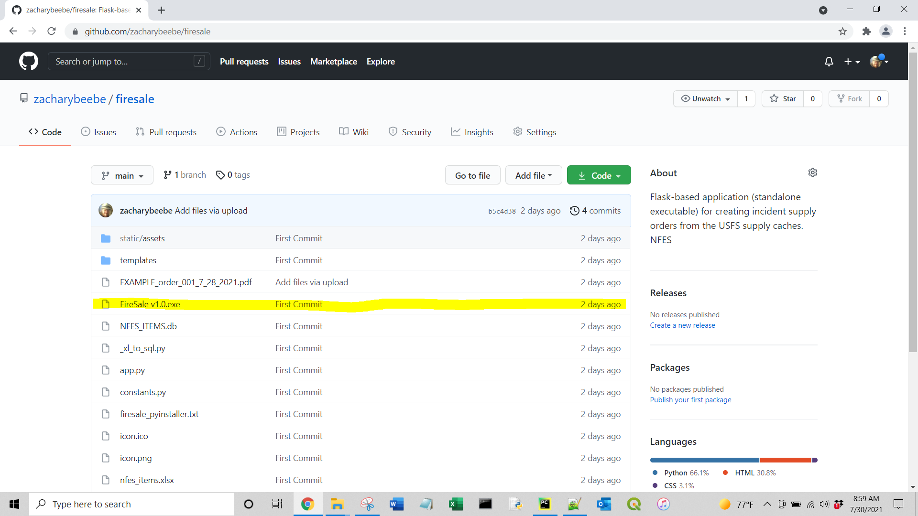

Click Download

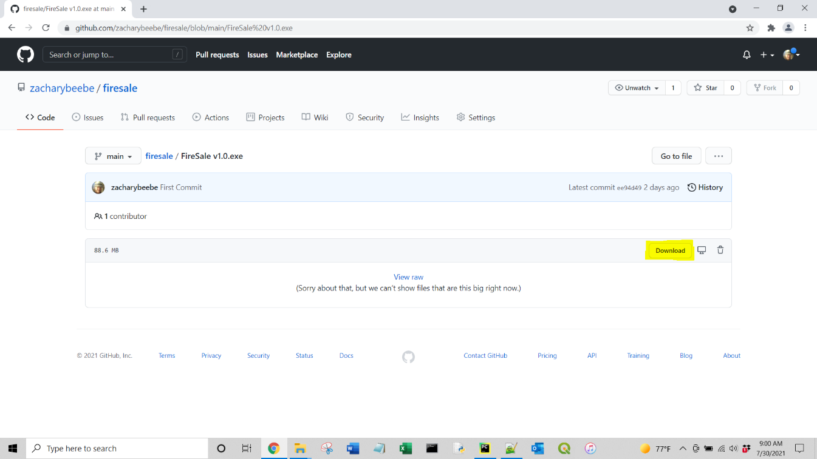

If you get security warnings, that is because the program does not have a certificate, it is not harmful though.

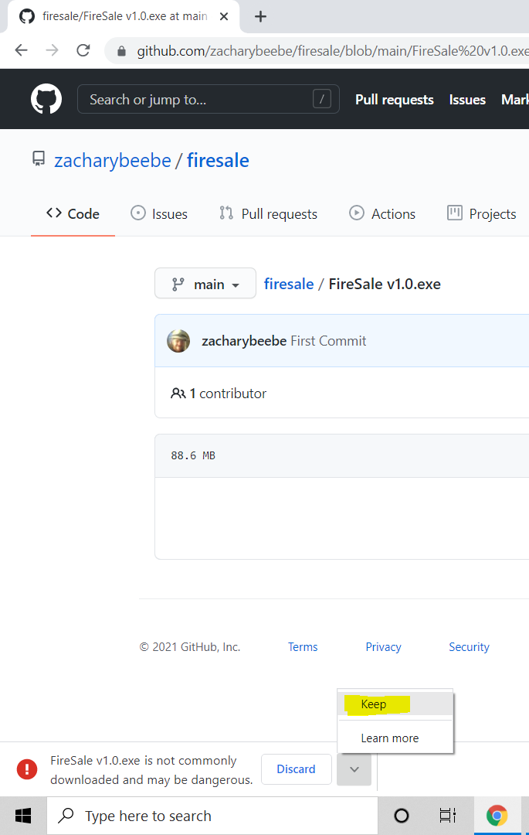

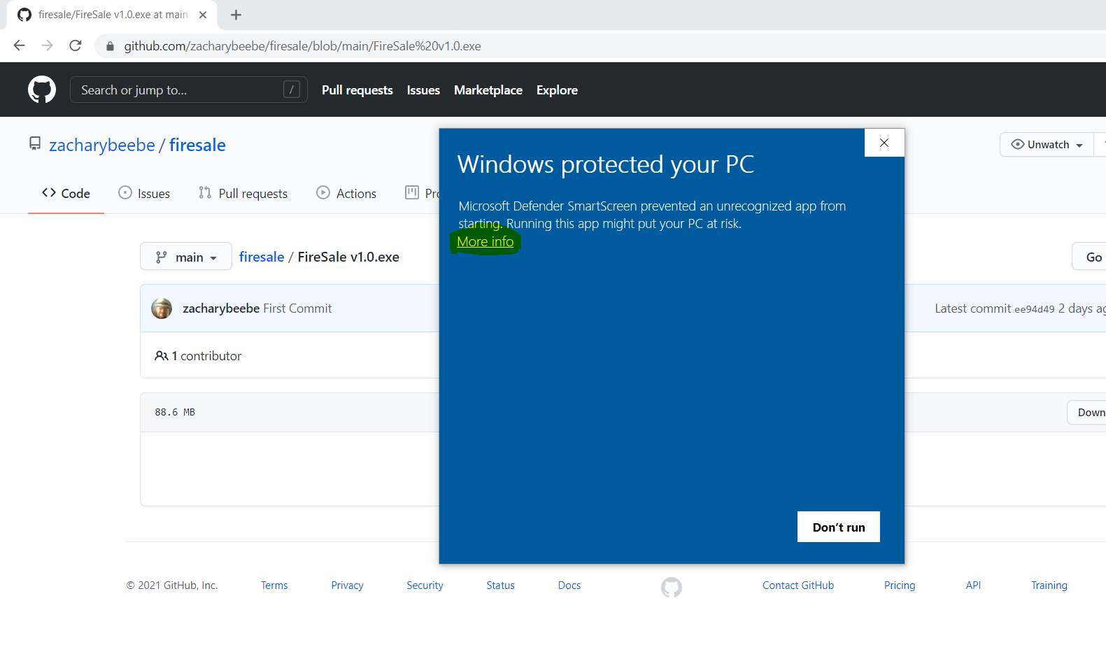

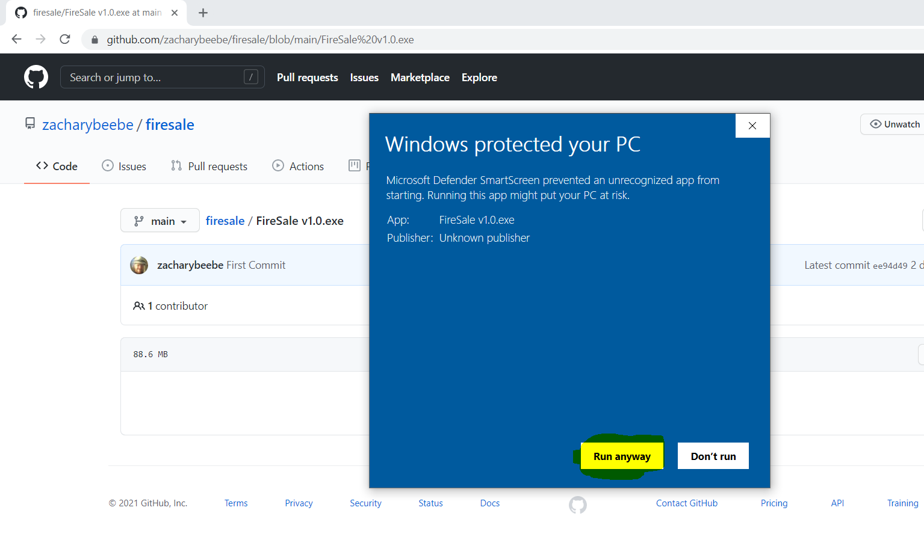

The program will boot up and then automatically open your default web browser, the program is not a website but it uses the browser as the user-interface.

Click Create to create a user, the user is used to keep track of and save orders and lists, you do not need a password.

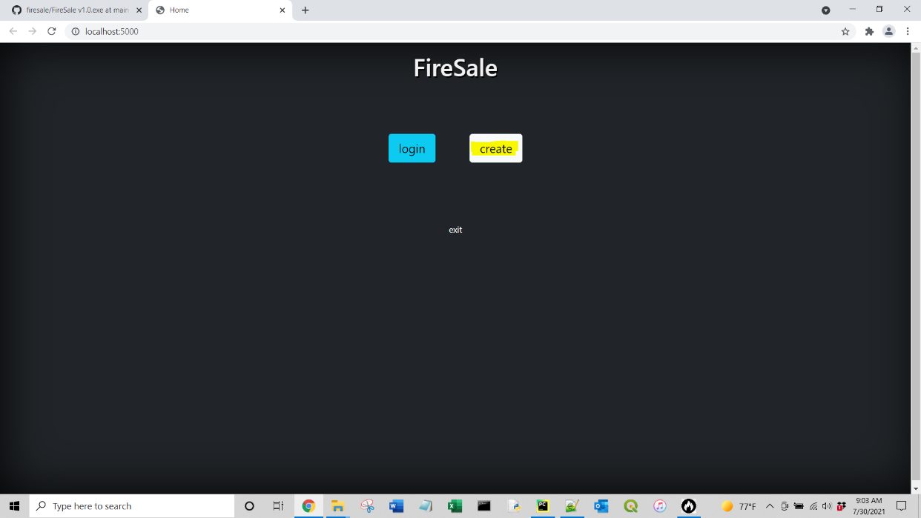

Enter your username and click Create.

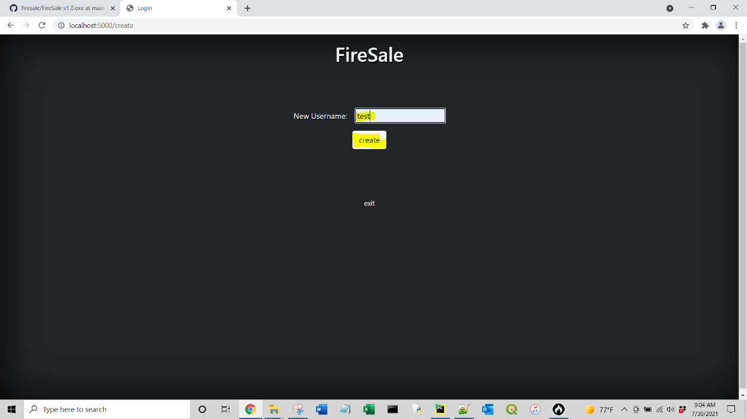

You will be redirected to the main search page. You can filter Items by Cache Supplied, NFES #, Item Class, Item Product, or Item Type.

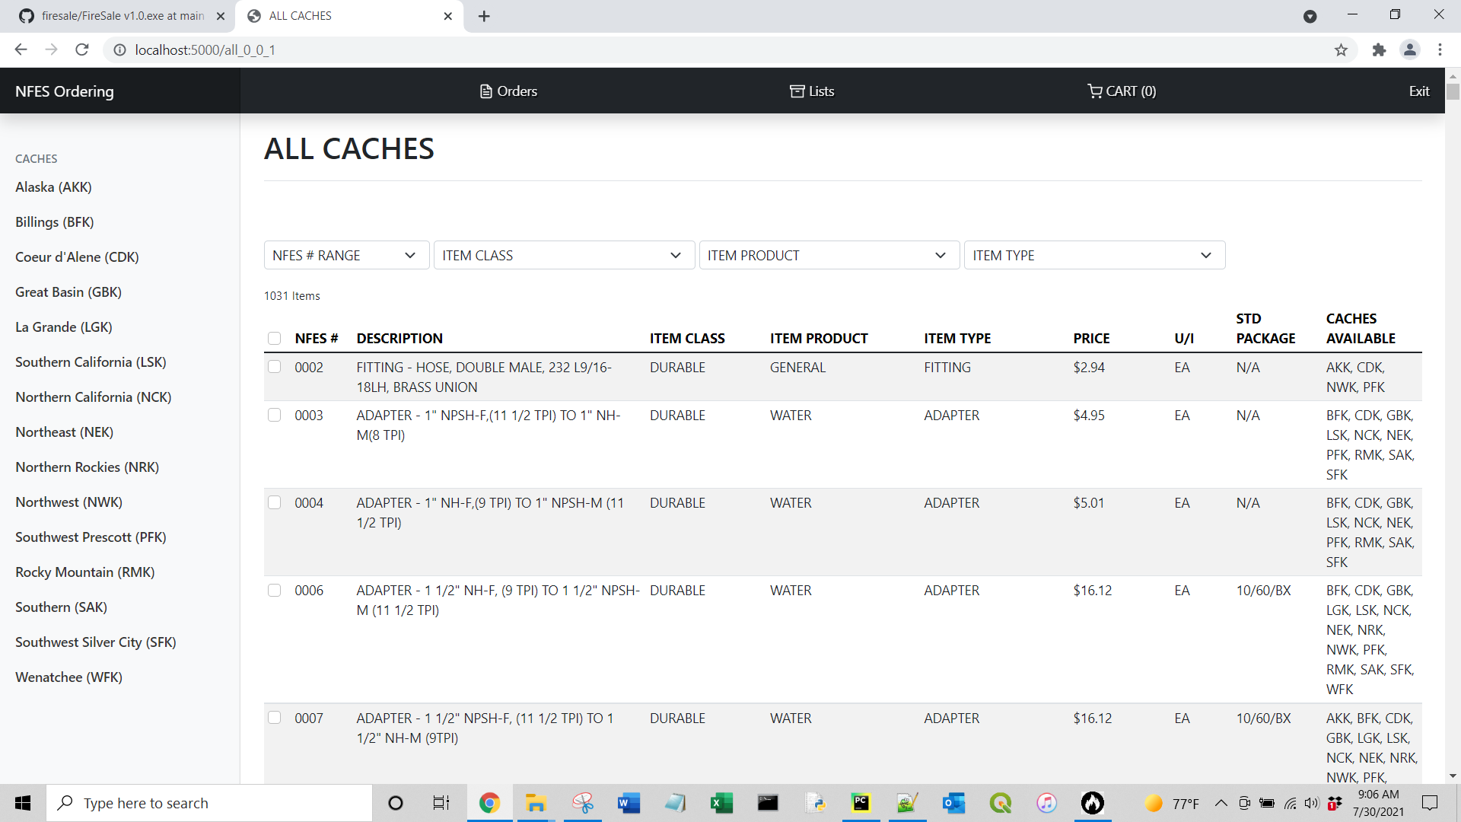

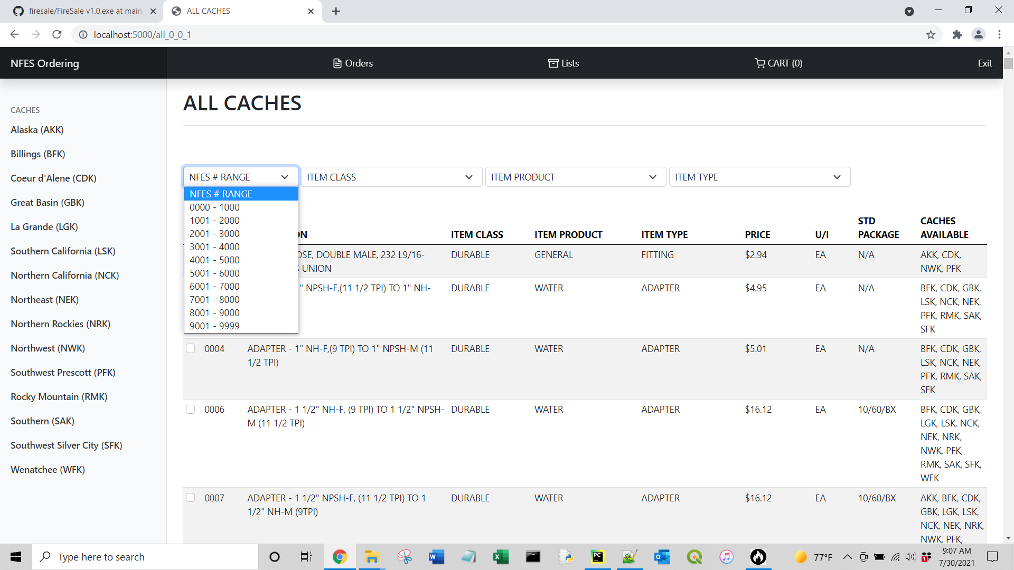

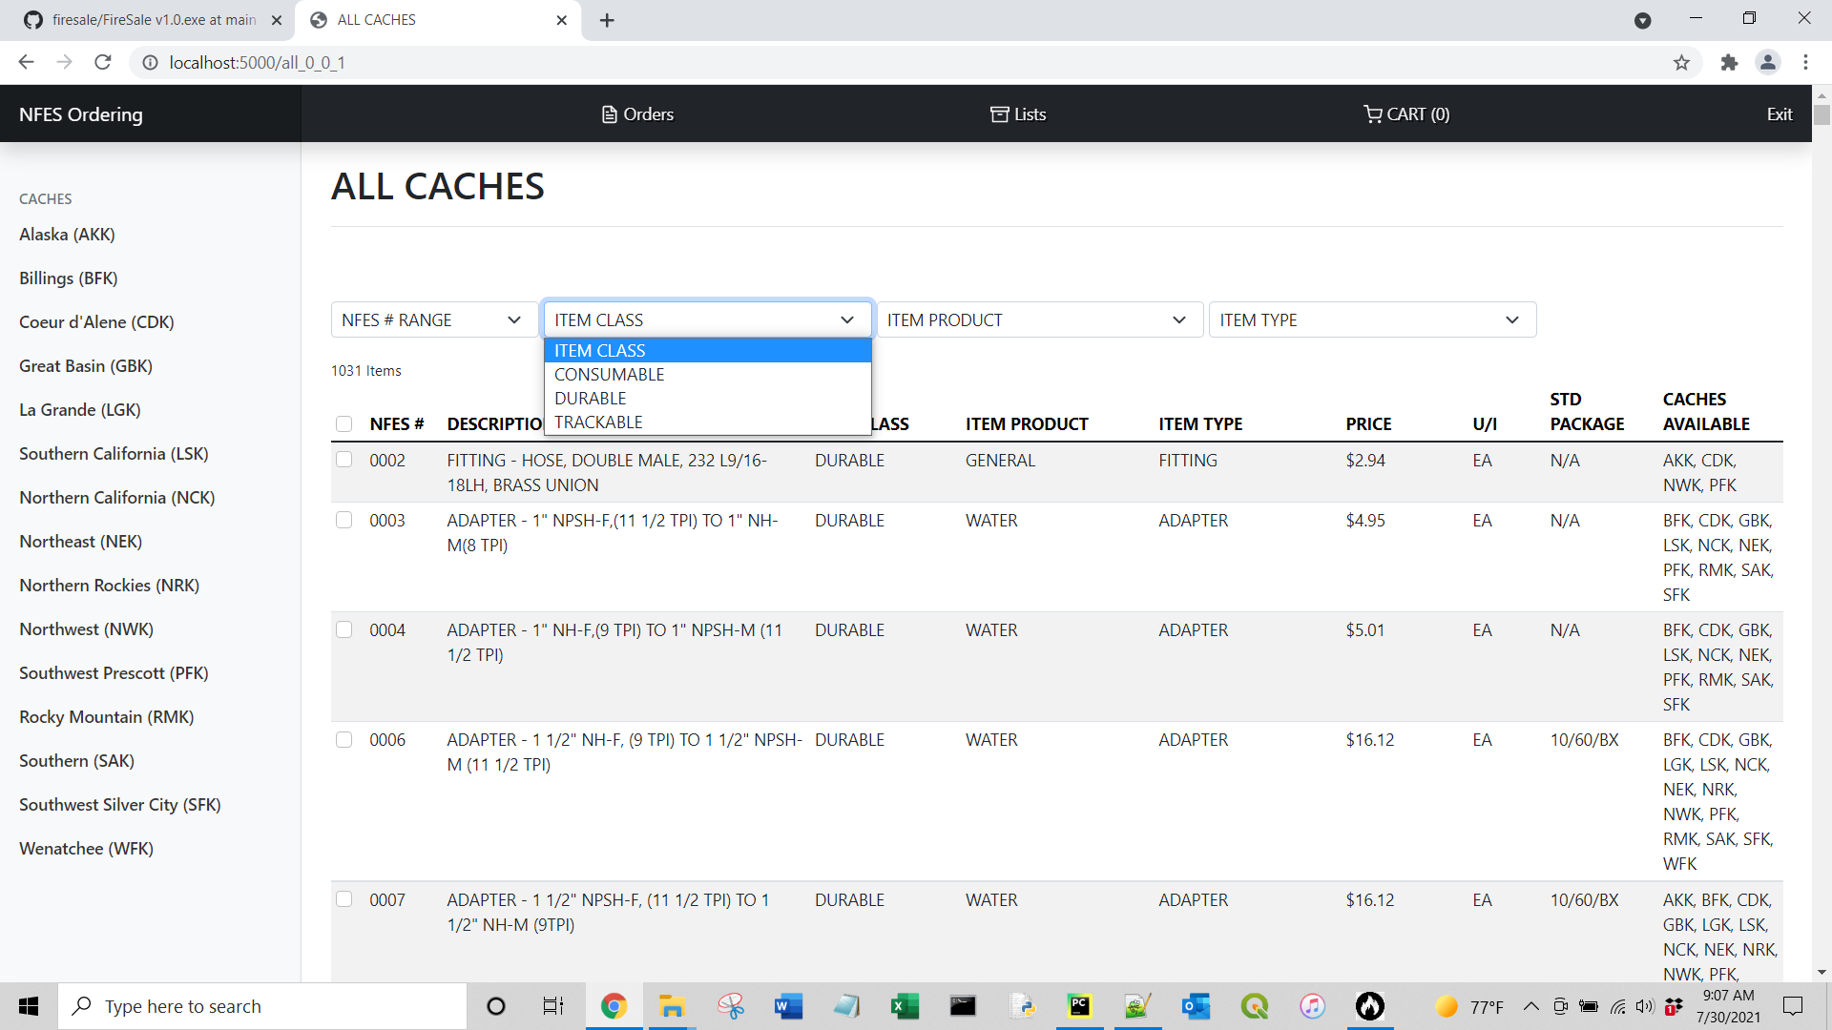

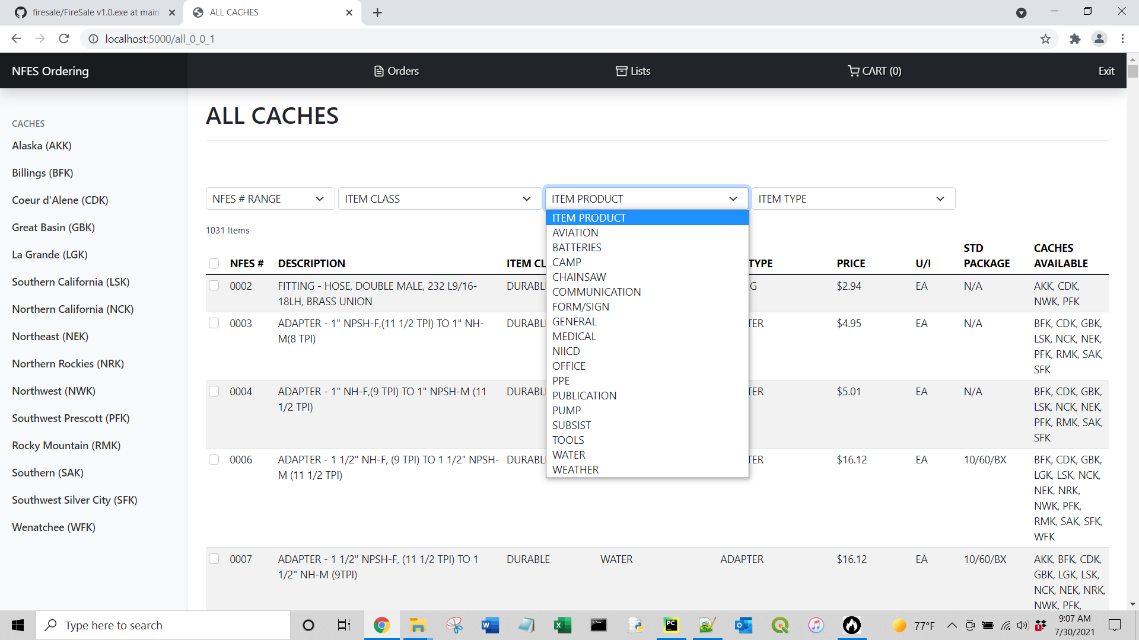

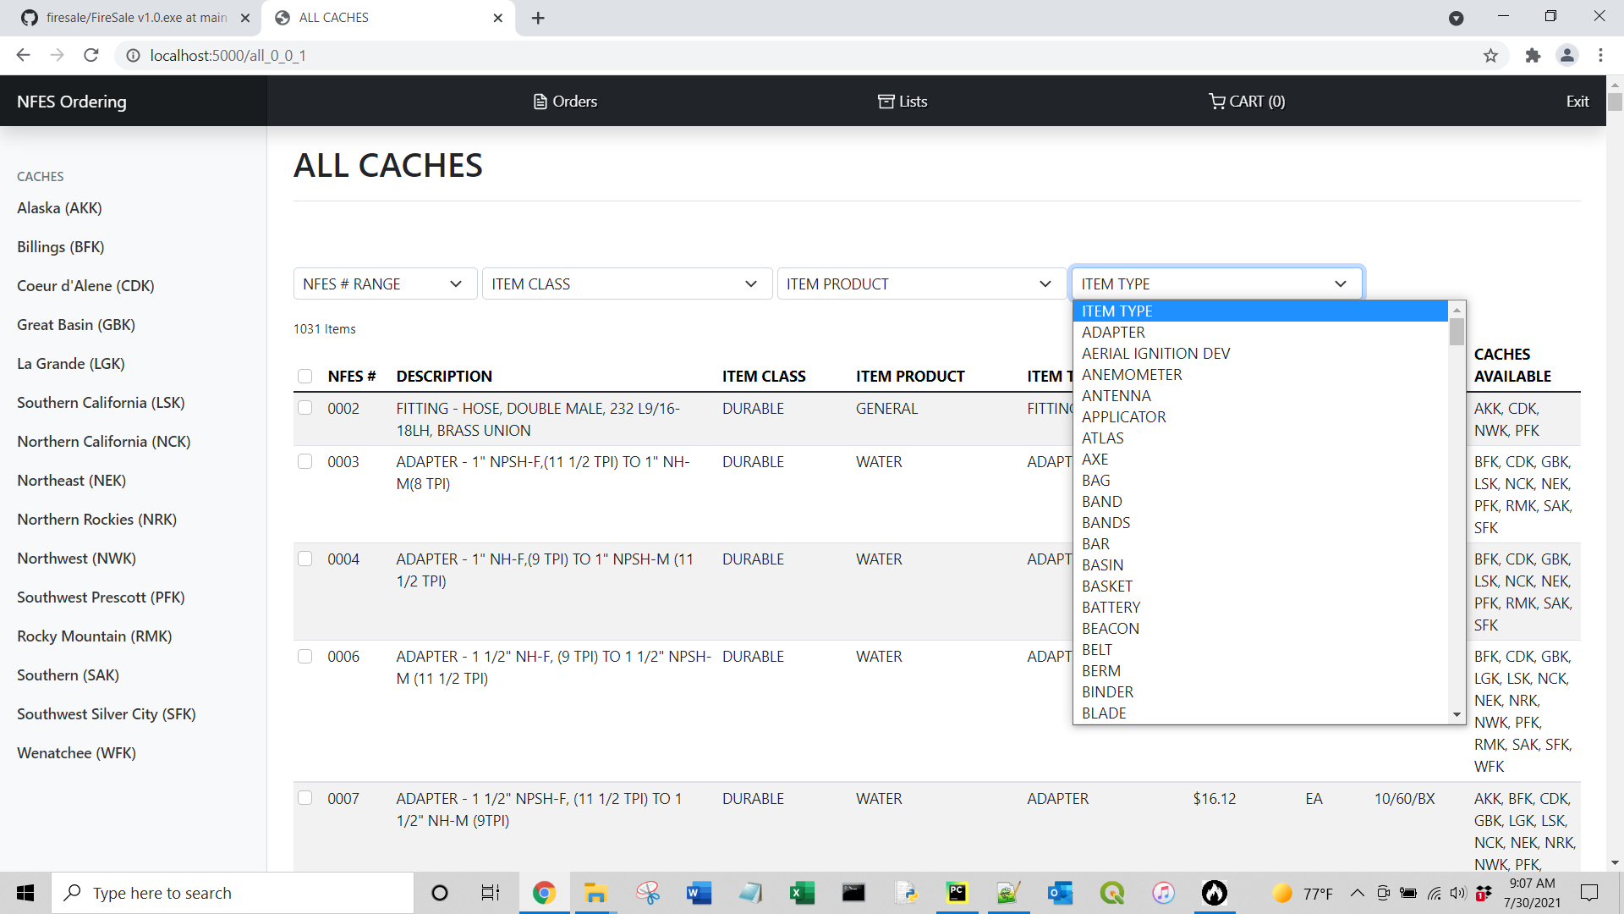

You can use the checkboxes to select one or multiple items to add to your cart.

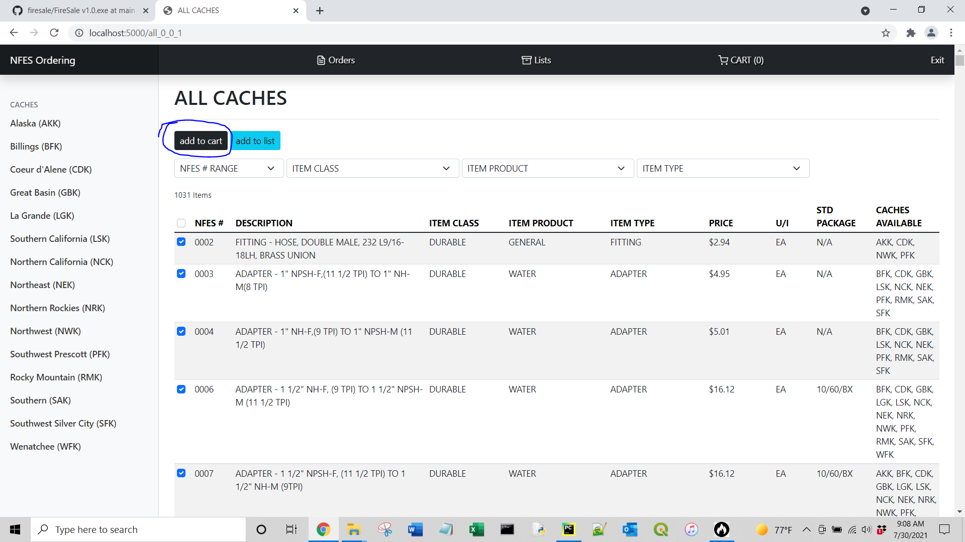

Once added you will get a message that items have been added to the cart and the cart size will increase. Click Cart to view your cart.

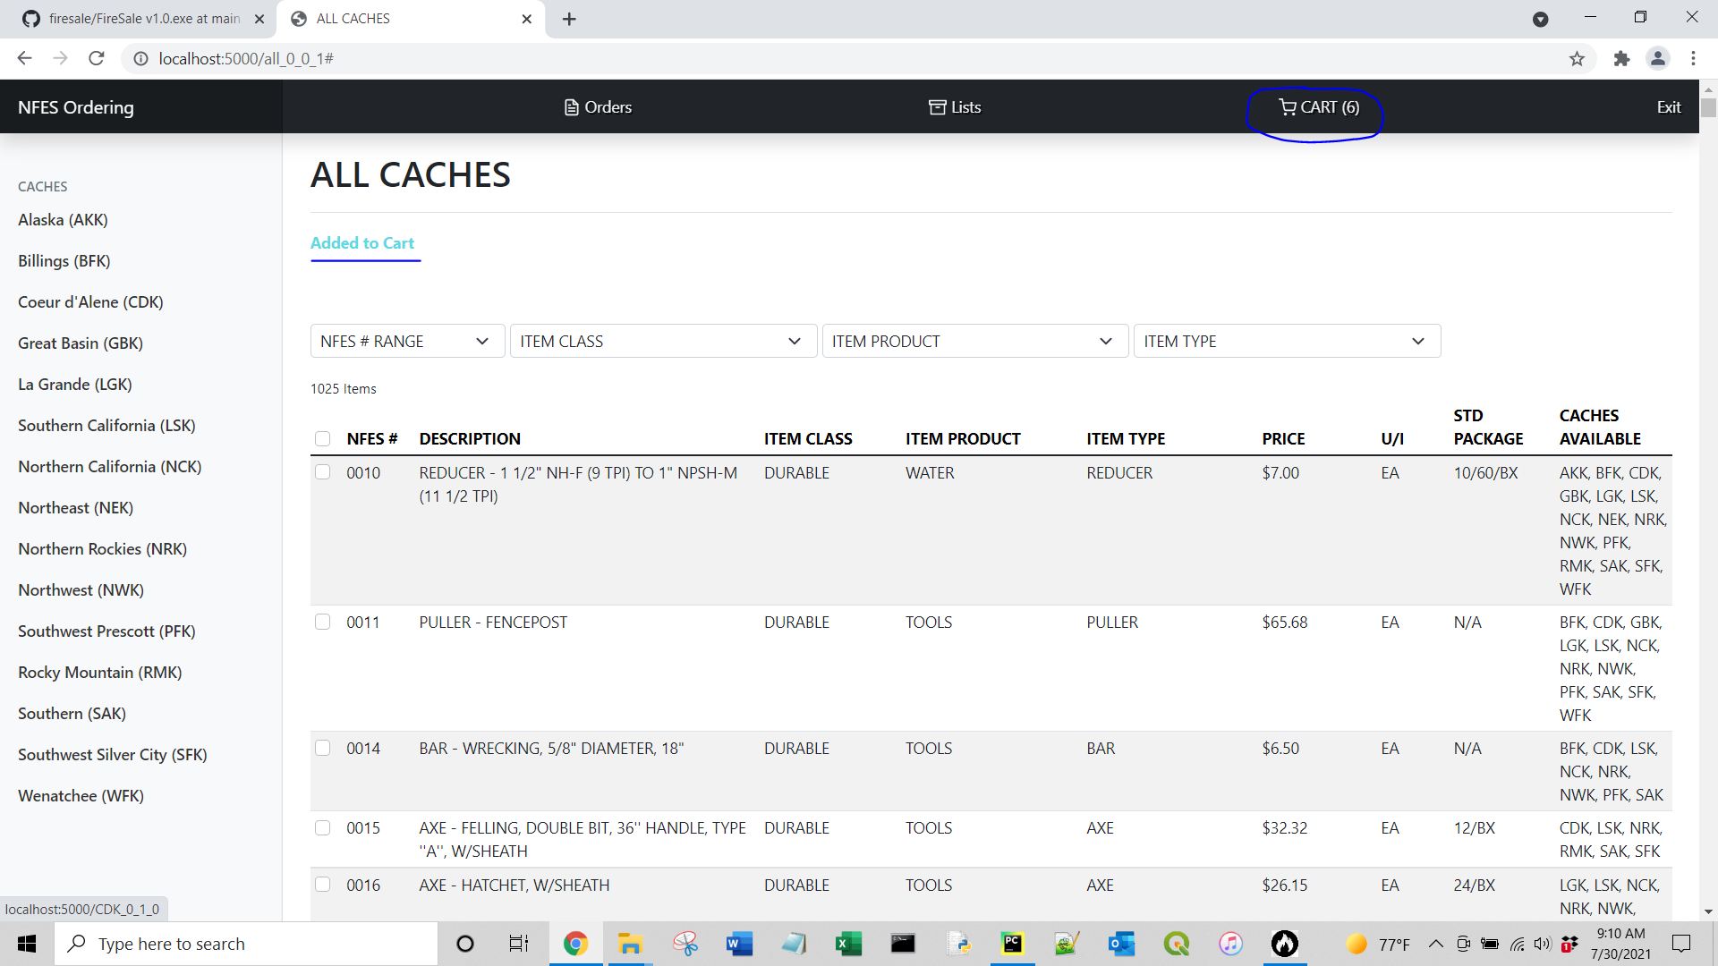

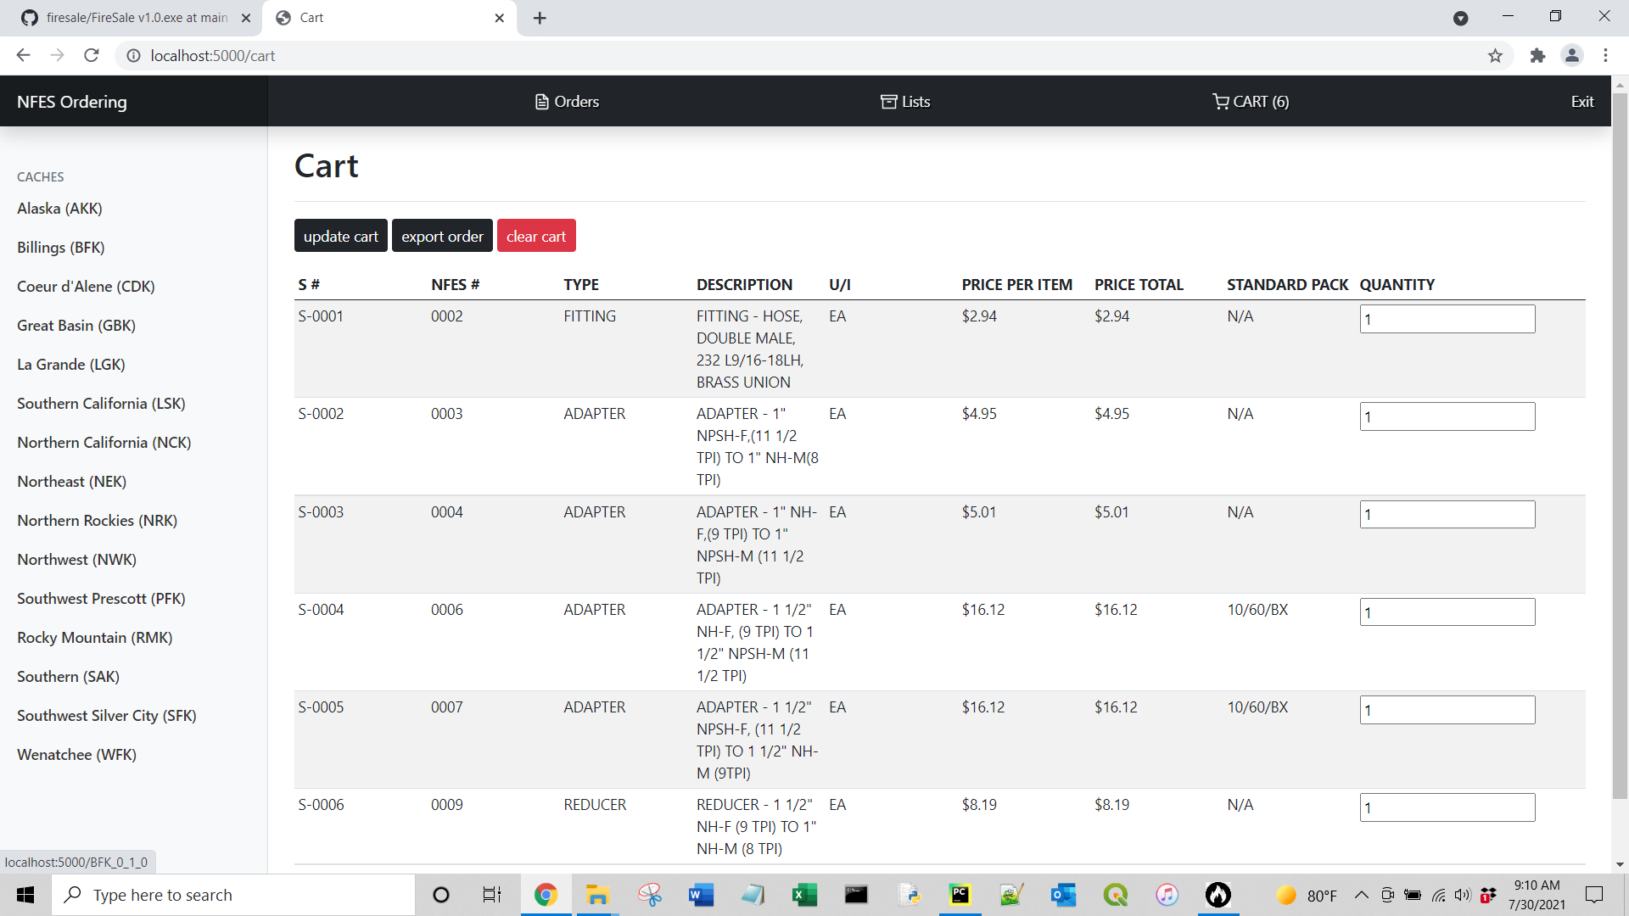

In the cart you can update the item quantity by changing the quantity in the input box and click Update Cart.

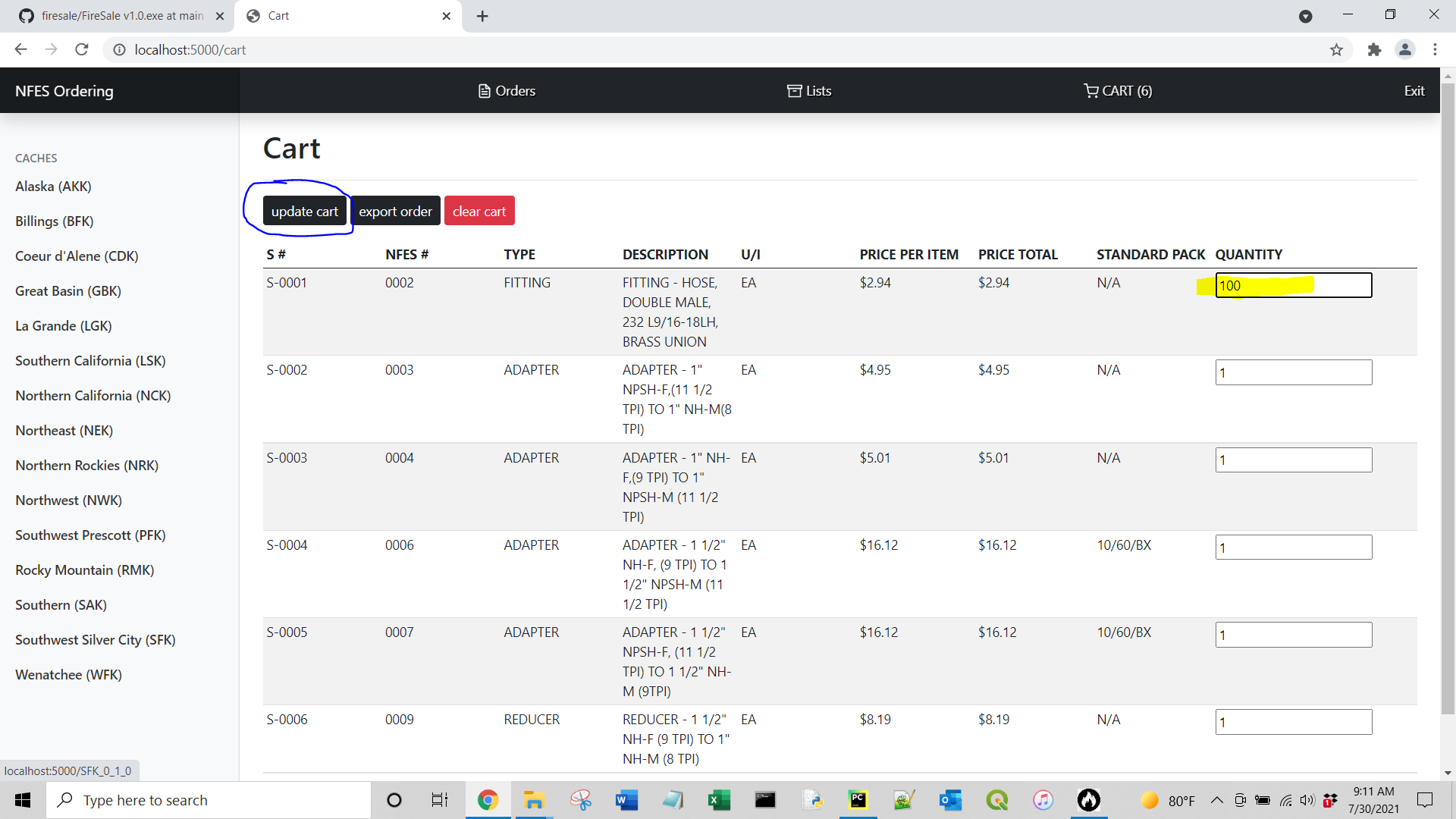

Once you are ready to export your order to a PDF, click Export Order.

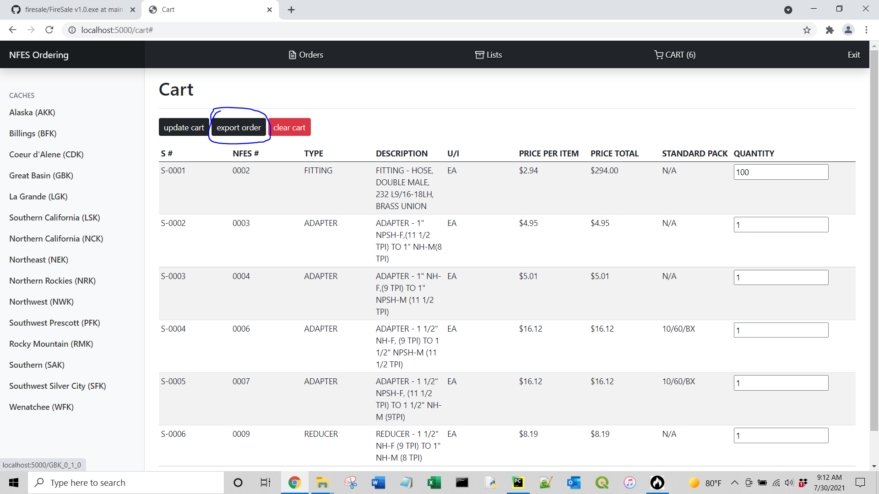

You will be redirected to a page where you can choose the Cache to order from.

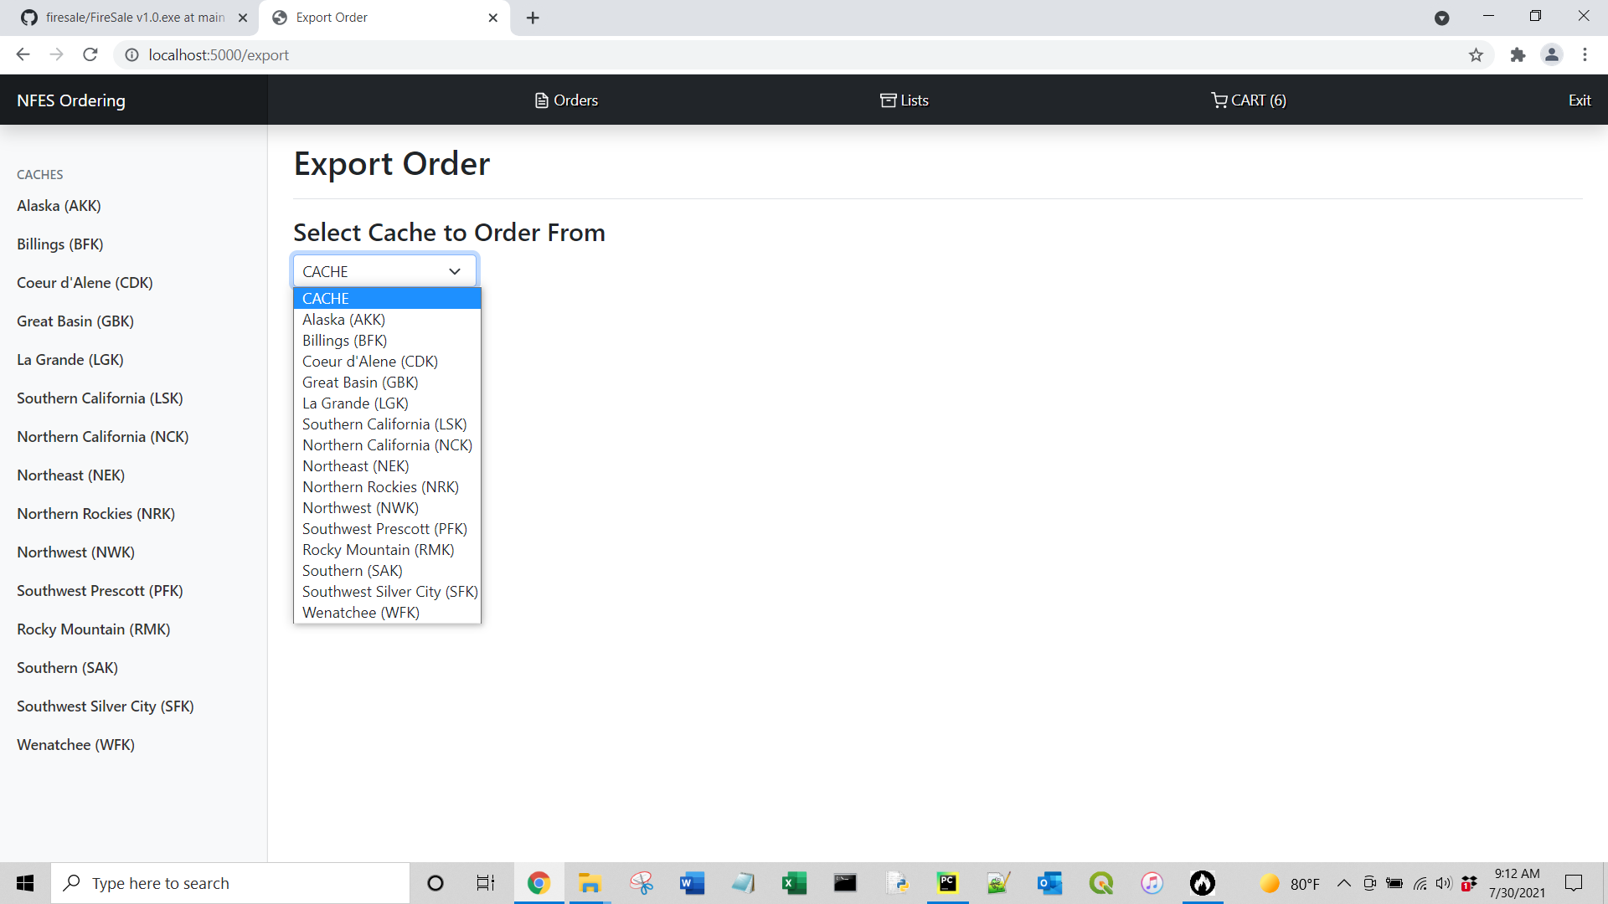

If the Cache you chose does not supply an item, you will receive a warning and a list of the non-supplied items and an option to delete the non-supplied items from the cart.

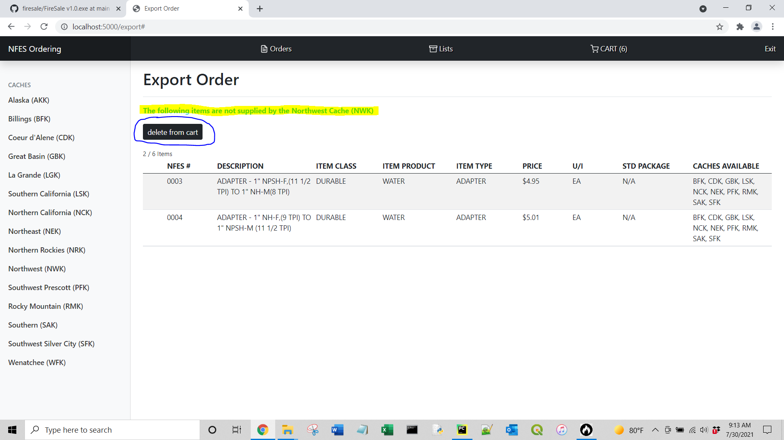

Once you delete the non-supplied items (or if all of your cart items were supplied by the chosen Cache in the first place) you will be redirected to the order form information page. The Cache-specific information will automatically be filled in. Fill out the rest of the info that is not automatically generated and click Create Order.

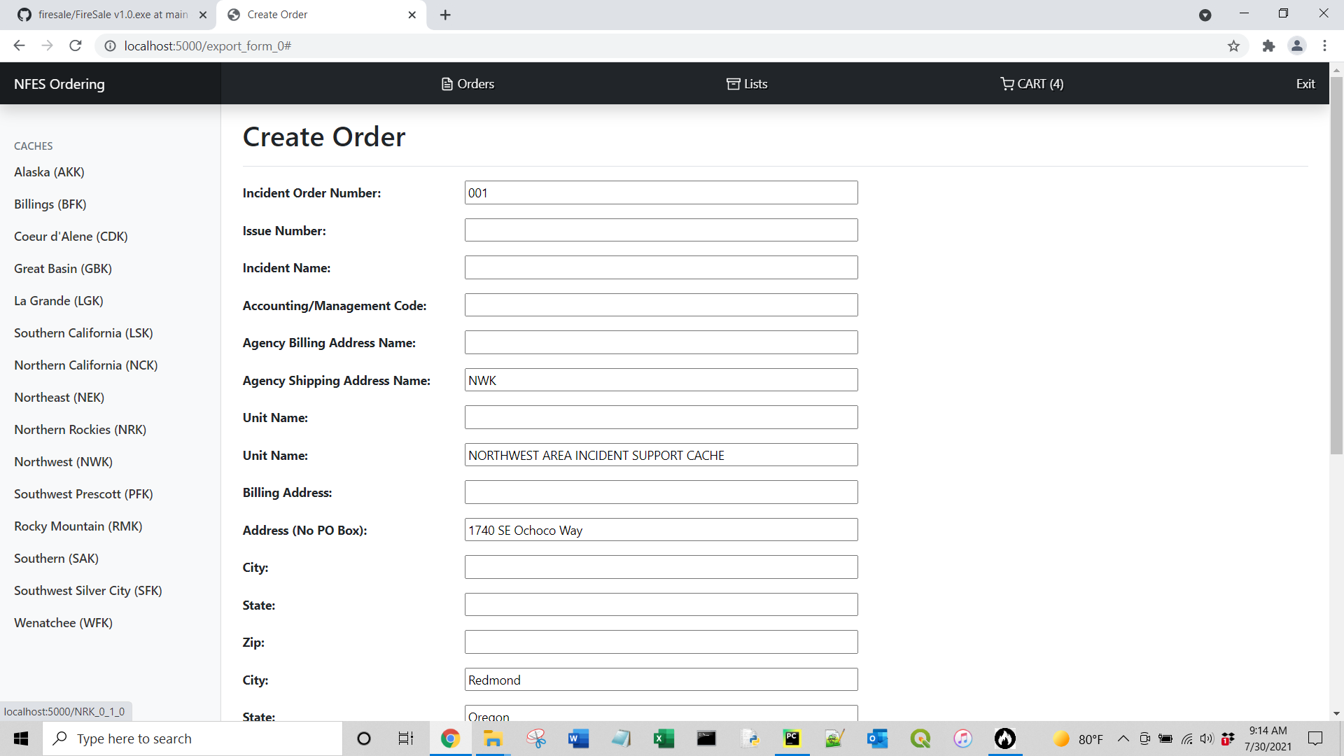

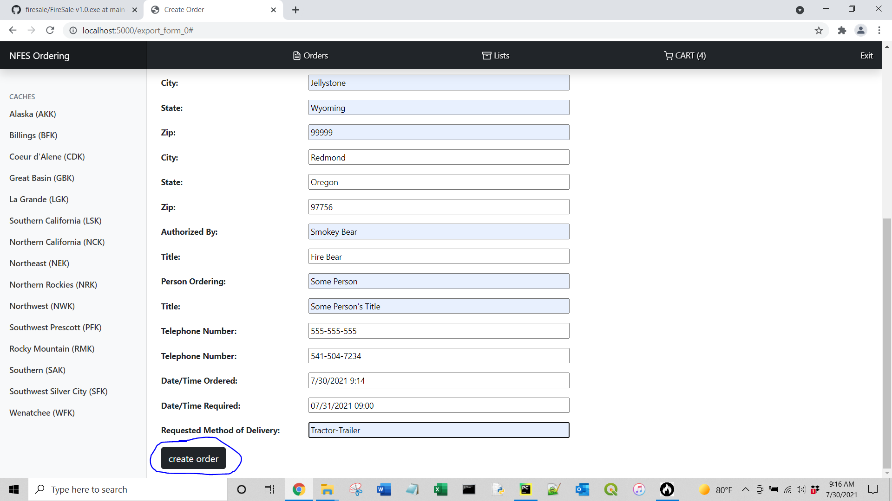

You will be redirected to a confirmation page that your order was successfully created, and you can click Download Order to download the PDF. And you can also Click Orders at the top to view all of your orders.

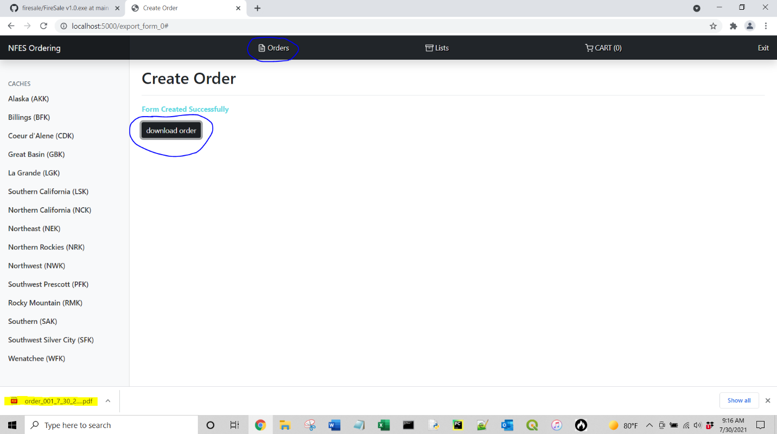

This is what the PDF will look like.

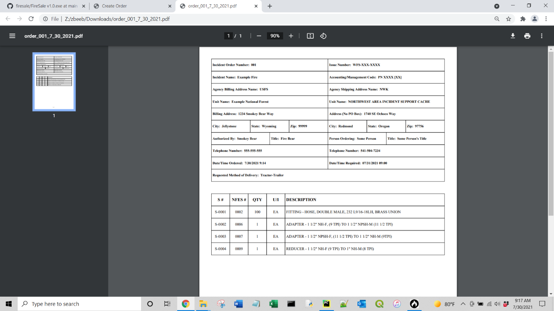

Orders Page

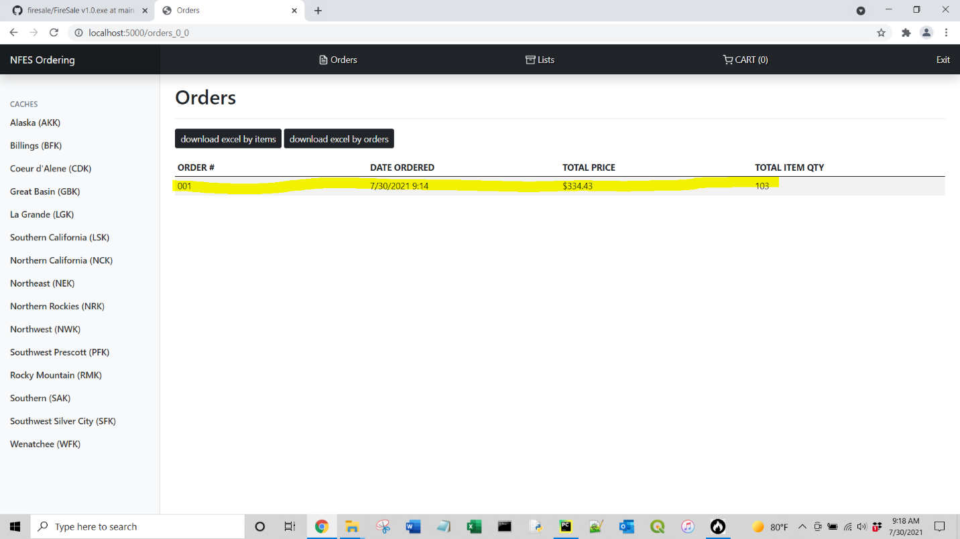

You can click on an order to view the contents of the order.

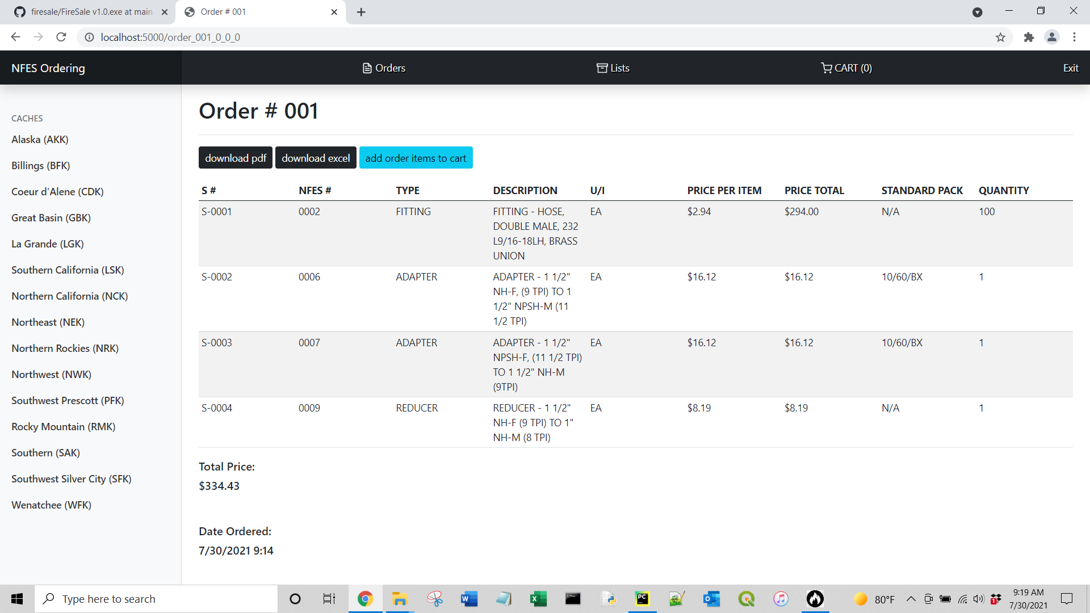

From an order, the cart or main search page, you can also click on an item to view more details about the item.

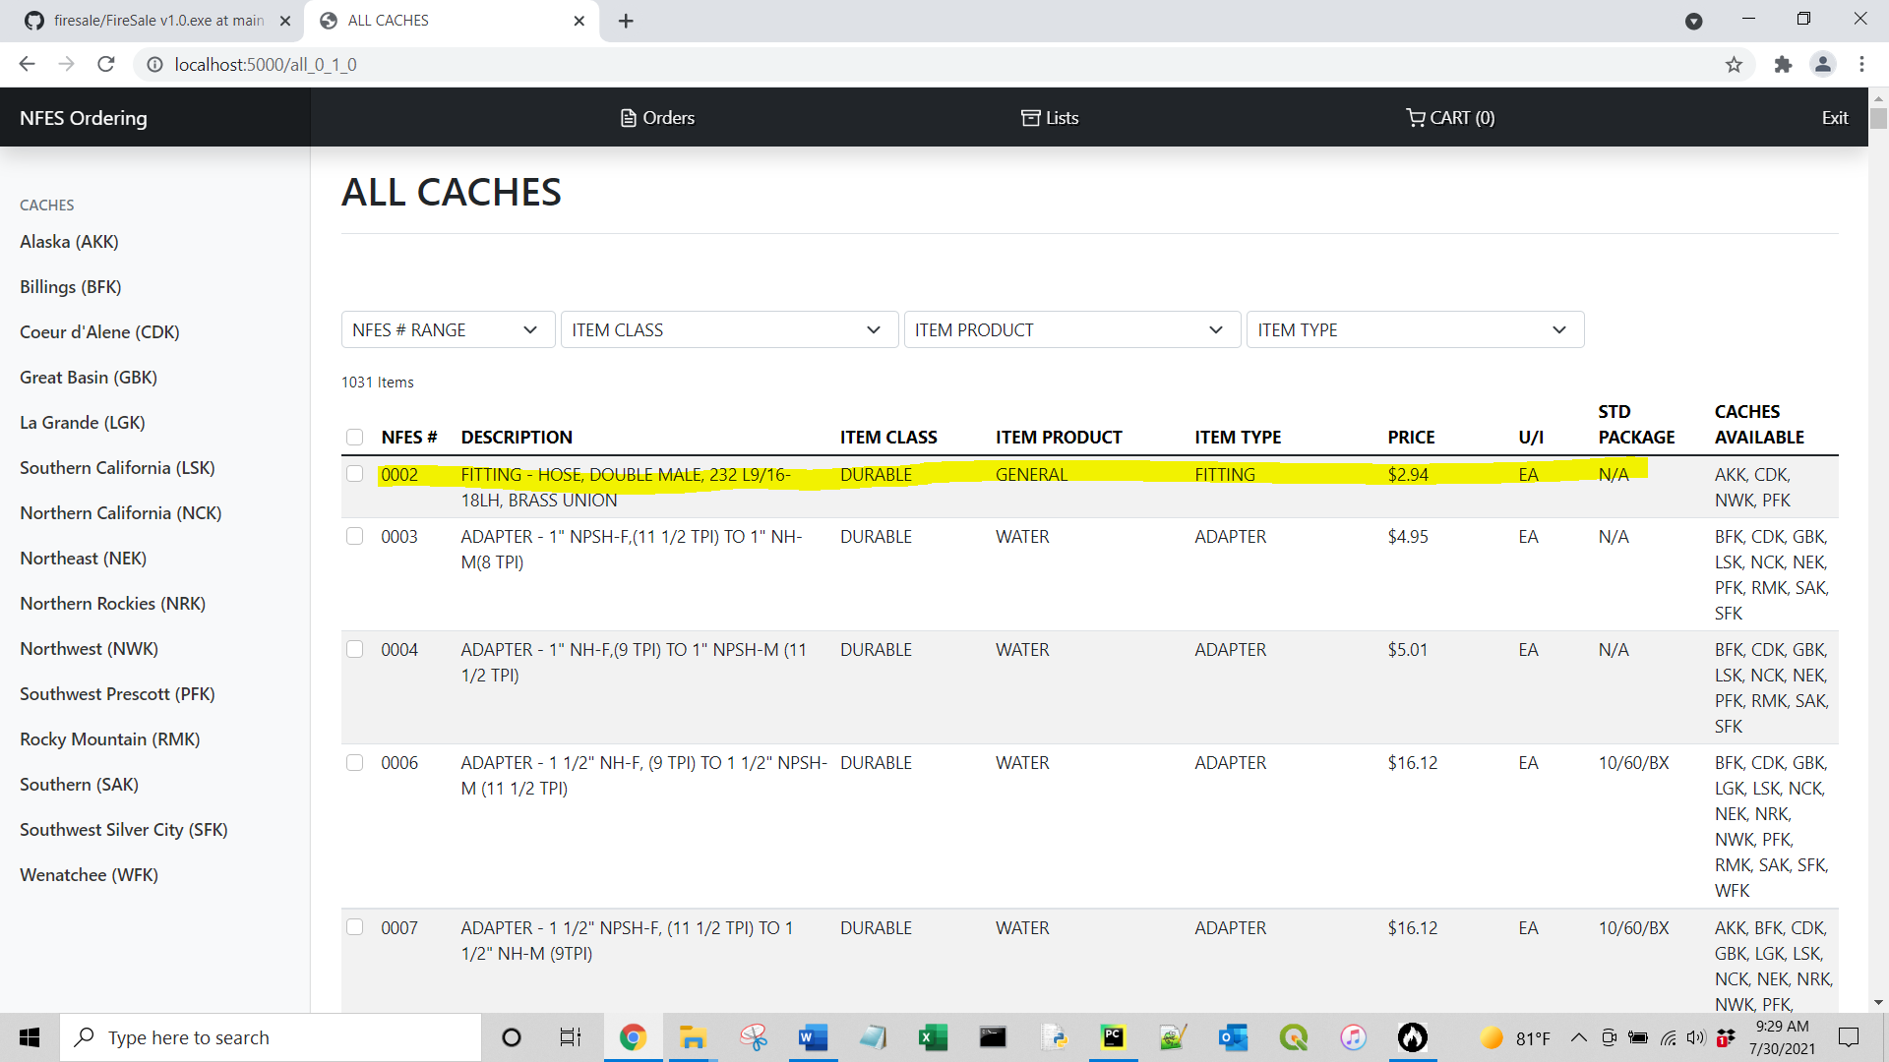

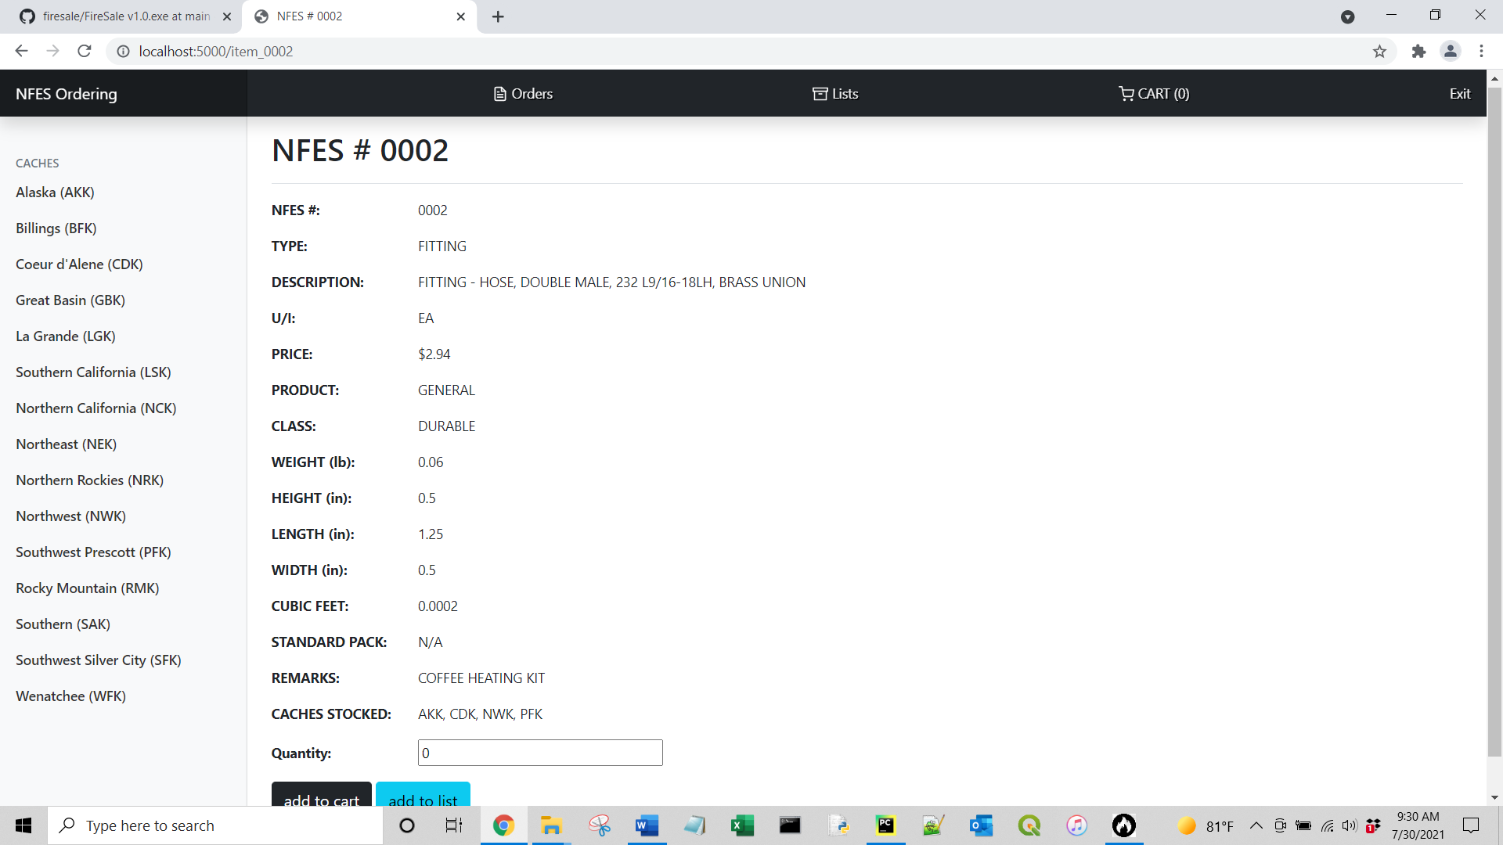

You can add or update your cart or list by filling in a quantity and choosing the appropriate button at the bottom. See more about lists below.

Working with Lists:

Lists are used to keep track of frequently ordered items or reference guides for Team Specific lists, an example would be a Management Team’s Hose Kit.

Click Lists at the top of the page to view or create lists.

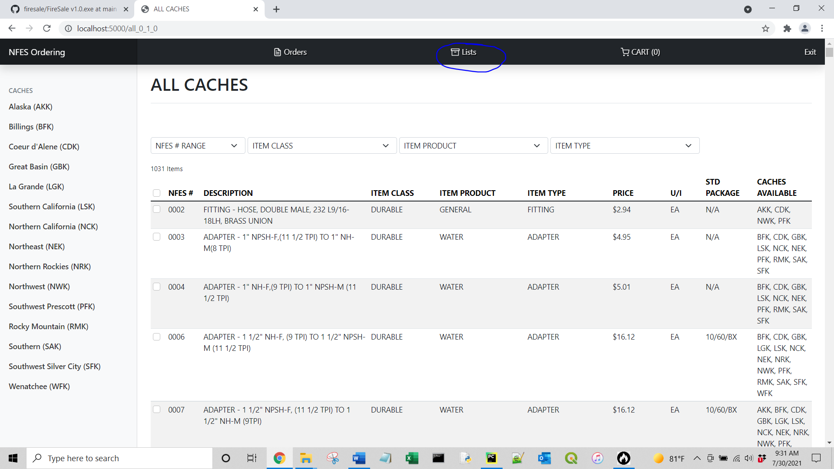

To create a list click Create New List and fill in the name for the list.

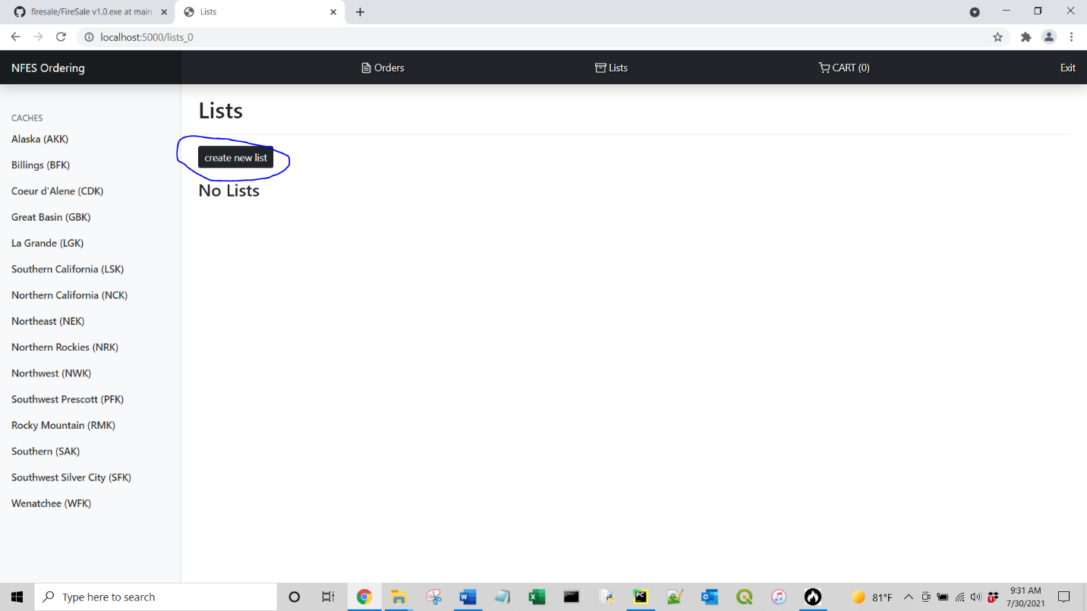

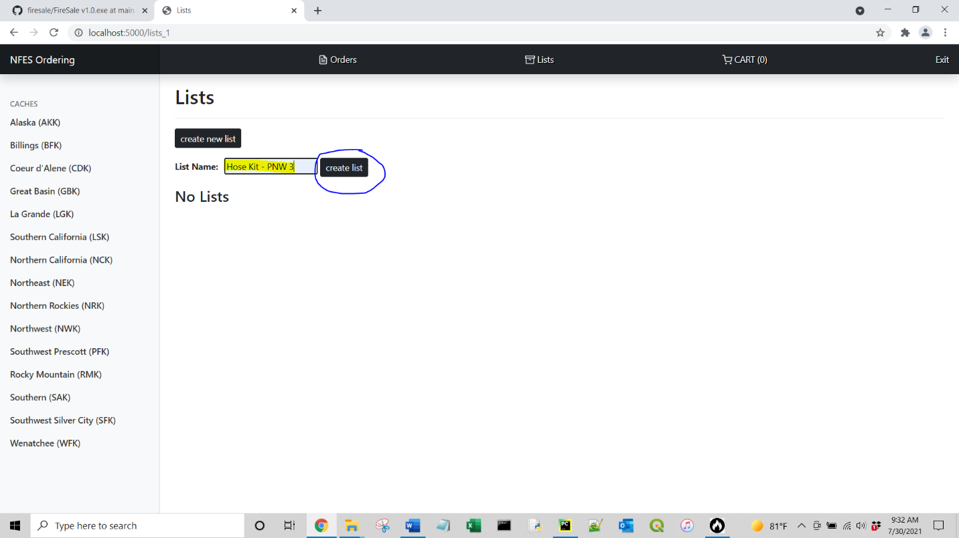

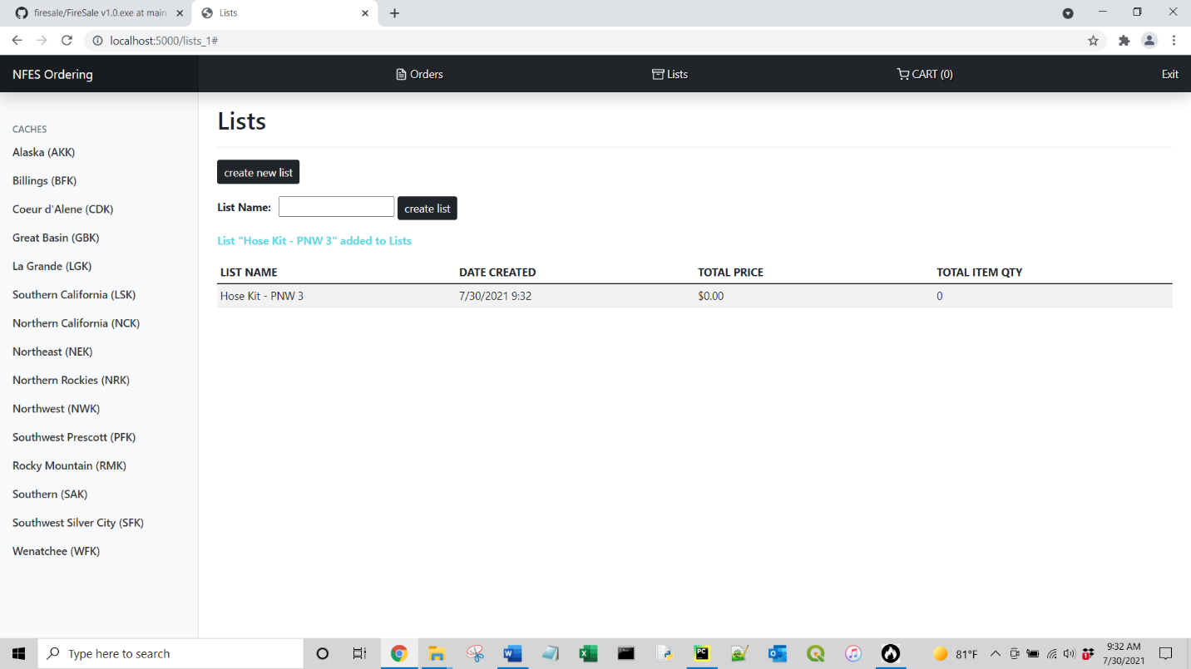

Adding items to the list is similar to adding them to the cart, except once you click Add to List, a dropdown menu will appear to select which list to add to. (The highlighted stuff below is showing an example of how to quickly find items by using the filters).

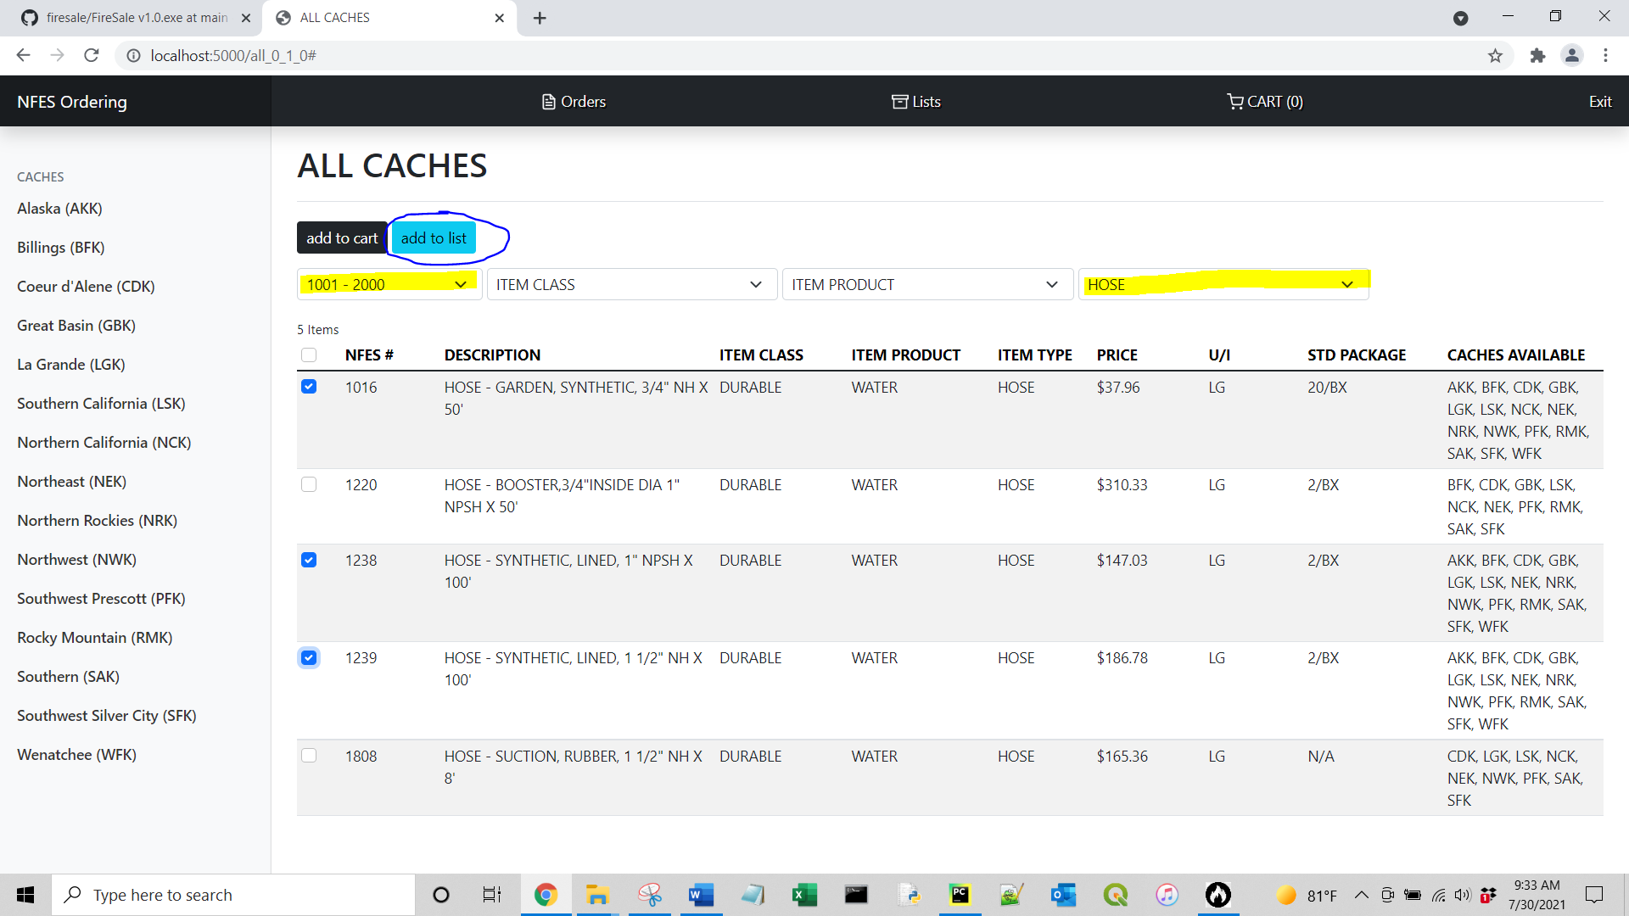

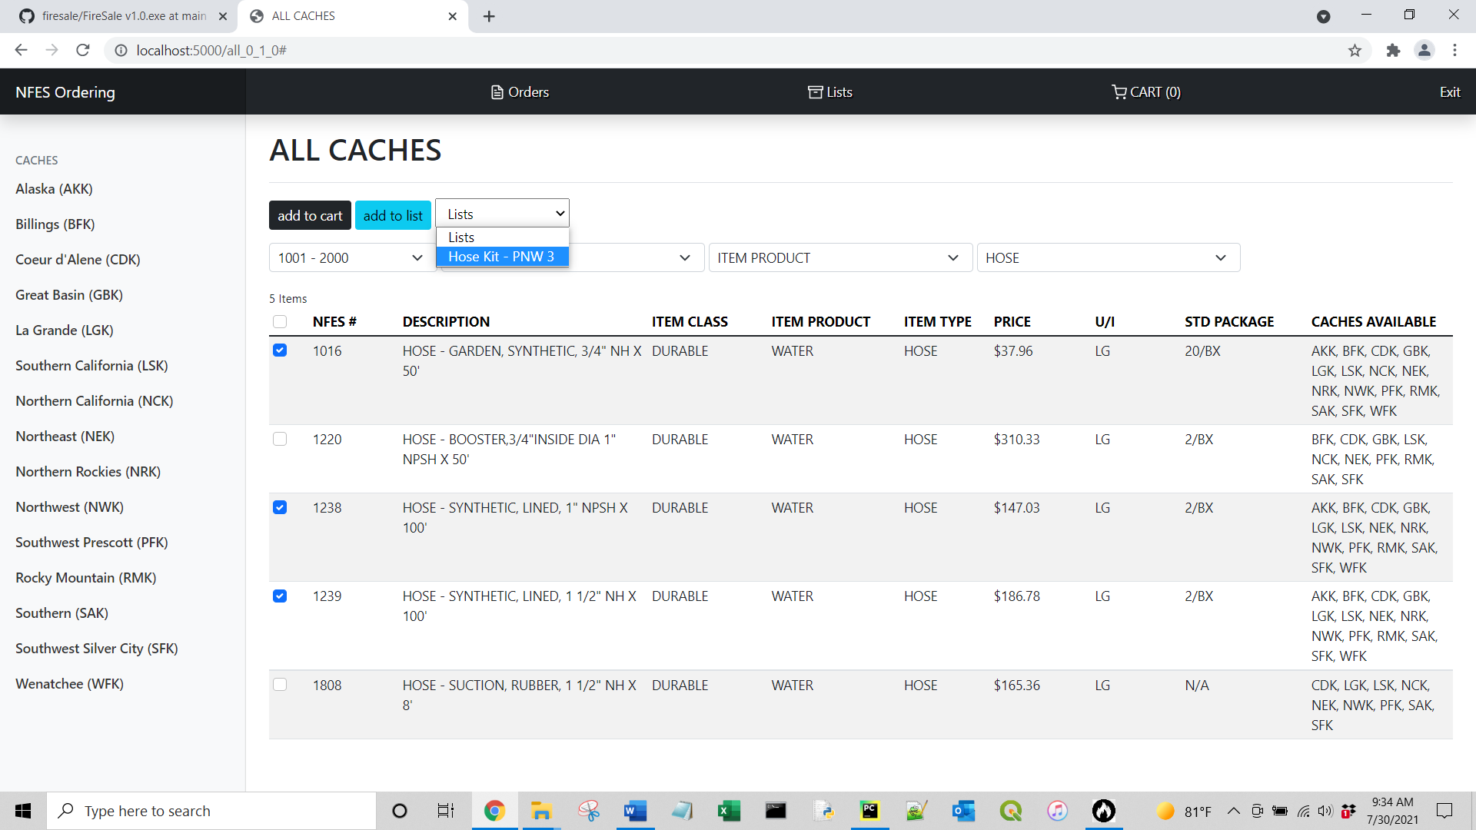

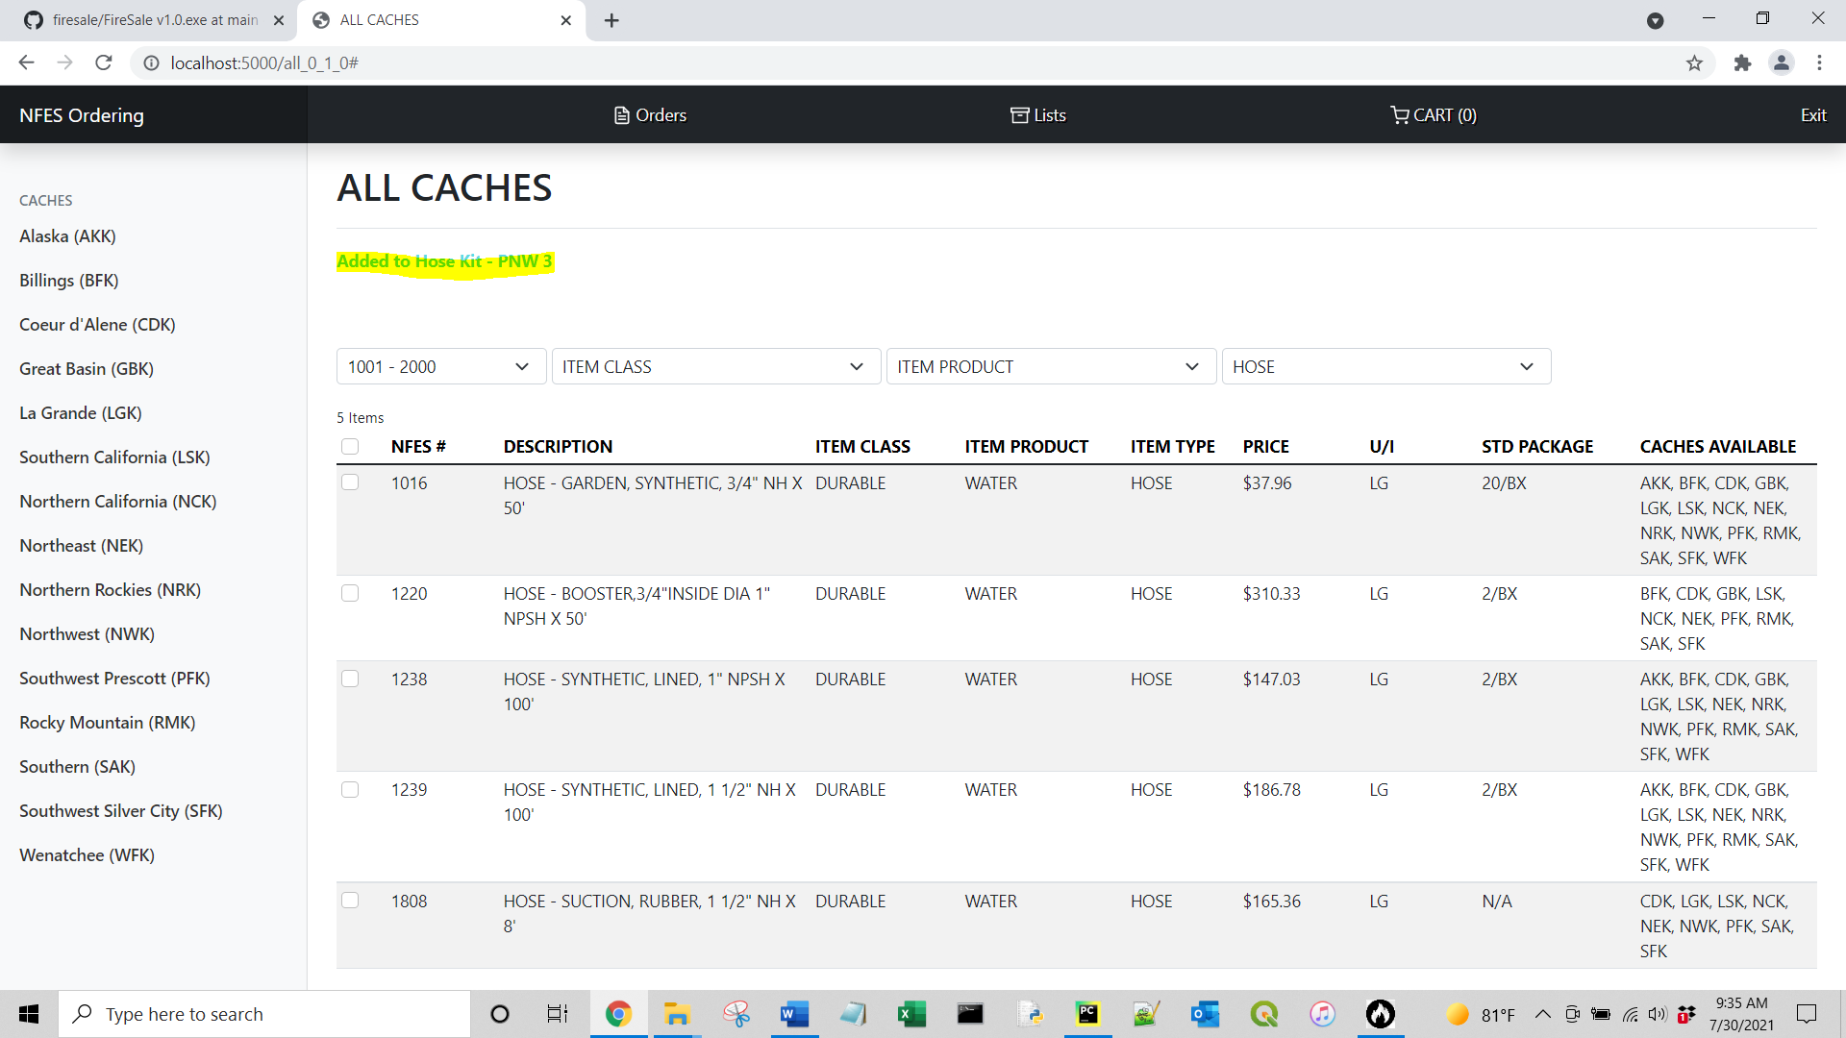

Like the cart, you can similarly update the quantity of the items in the list by filling in the quantity and clicking Update List.

If you would like to add the list items and their quantities into your cart, click Add List Items to Cart and your cart will be populated.

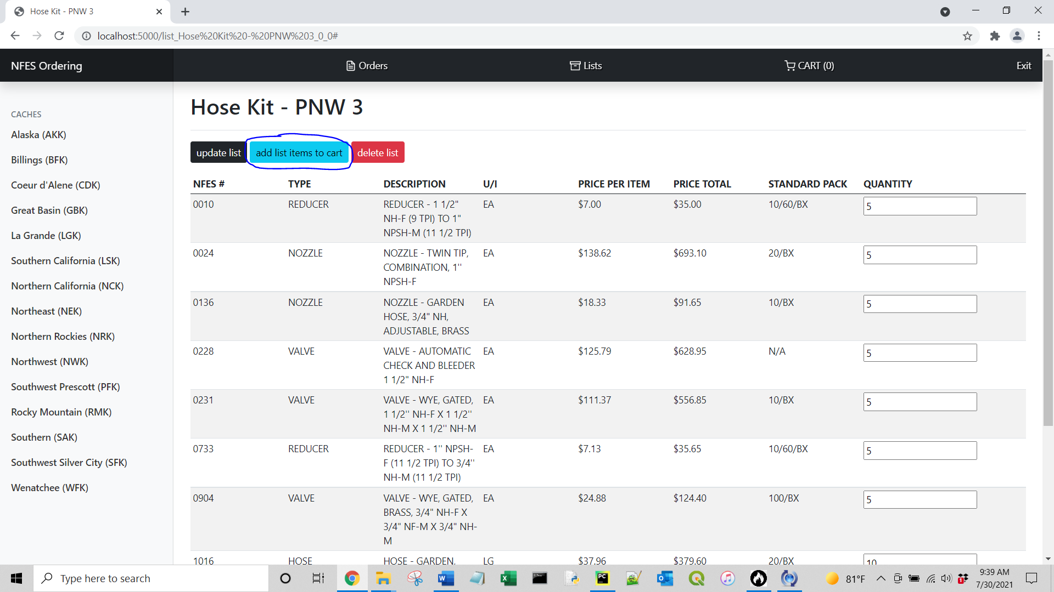

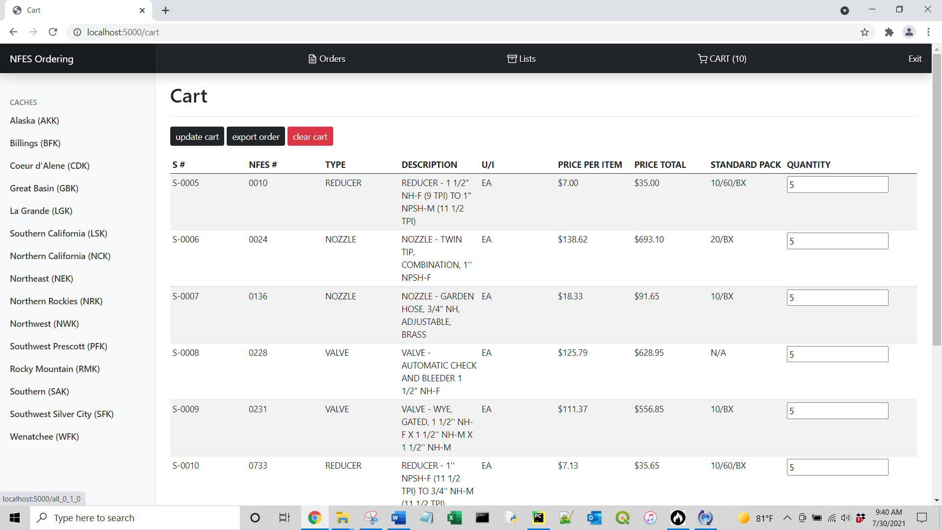

OTHER NOTES

* S numbers are tracked for the entire day, and they are reset to S-0001 for every new day.
* S numbers are sorted by NFES # in ascending order.

If you need to delete a user from the database, type into the browser address bar “delete_user” AFTER the “localhost:5000/”

Address Bar should look like this: <http://localhost:5000/delete_user> and click enter.

Type the username you would like to delete into the input box and click Delete.

